Online Bus Ticket Booking System

Requirements-:

1. User friendly interface-: the software should have an intuitive and easy to use interface that allows users to search for bus routes, select seats and make payments quickly and easily.

2. Multiple payment options-: the software should support multiple payment options , such as credit cards, debit cards, net banking and mobile wallets, to accommodate different user preferences.

3. Real time bus tracking-: the software should have a feature that enables users to track the real time location of the bus and estimated arrival time.

4. Customizable search filters-: the software should have customizable search filters that allow users to search for buses based on their prefered timings, bus type and other prefrences.

5. Integration with other services-: the software should integrate with other services like hotels, tour operators, and car rentals to provide a seamless travel experience to users.

6. Multilingual support-: the software should support multi languages to cater to users from different regions.

7. Secure payment gateway-: the software should have a secure payment gateway to ensure the safety of users financial data.

8. Customer support-: the software should have a customer support system in place to handle user queries, complaints, and feedback. This can include a live chat, email support, or phone support.

9. Mobile compatibility-: the software should be mobile friendly and compatible with different devices and platforms , including android & IOS.

10. Loyalty and rewards program-: the software should have loyalty and rewards program to encourage repeat bookings and retain customers.

Risks-:

If the ticket booking software is not secure, it may lead to a data breach resulting in the theft of customer data financial data & other information.

Staff should be trained in data security best practices to avoid human error.

Regular software update should be performed to keep the system up to date & fix any bugs.

Online payments should be secure.

**Configure JIRA for managing the project to solve the identified problem.**

**STEP-1: In the name icon enter your project name and click on**

**Create**

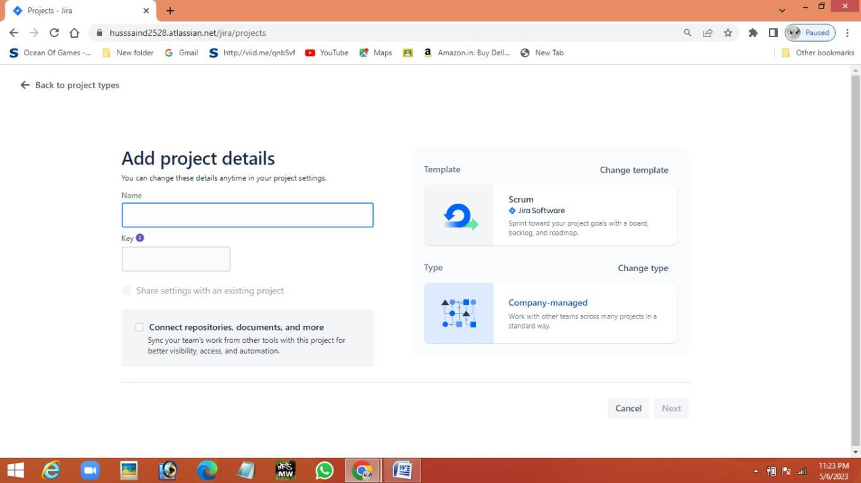

**STEP-2: Click on backlog button and create issue in backlog. Drag**

**the issues from backlog to sprint.**

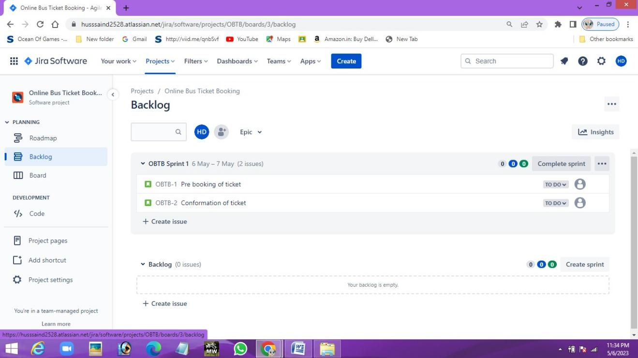

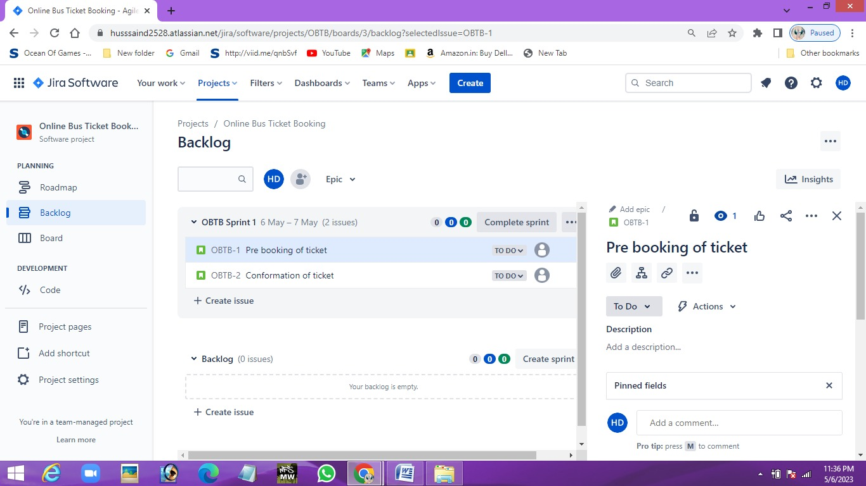

**STEP-3: Click on board and drag the issues to its respected fields**

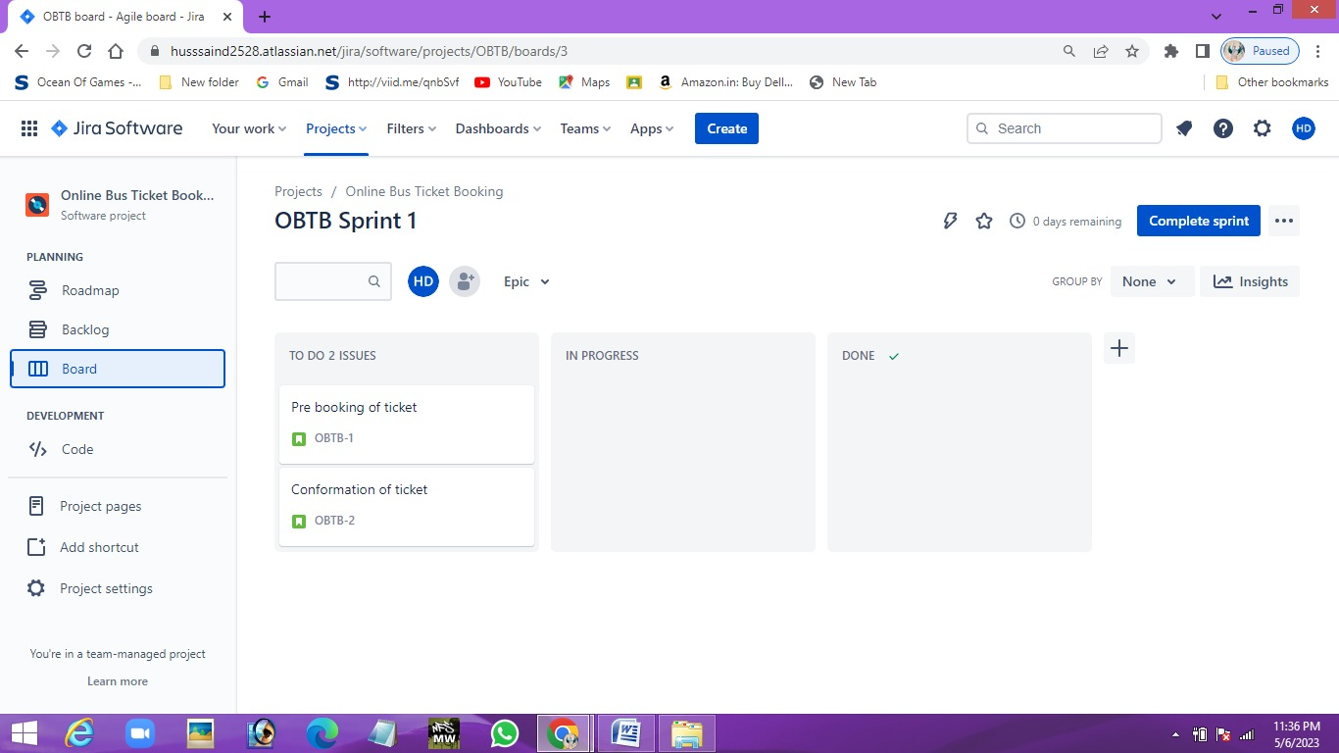

**STEP-4: Click on roadmap and create Epic and child process**

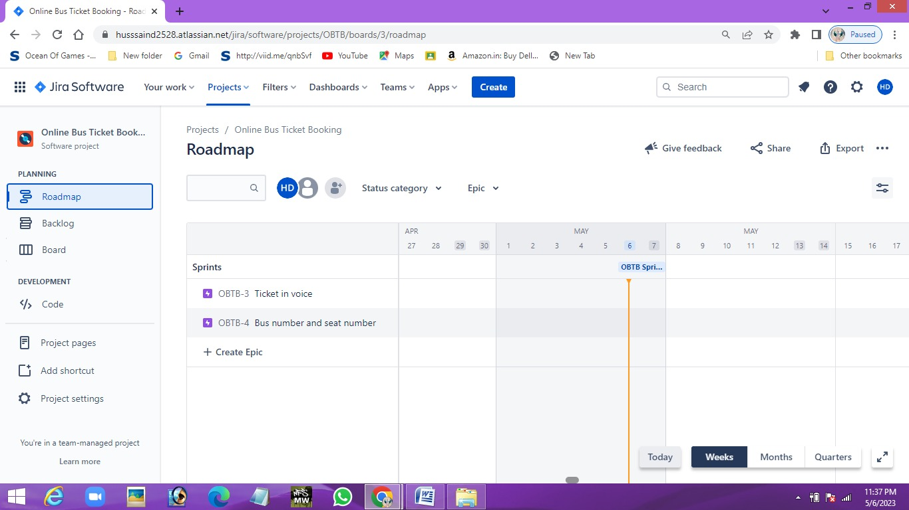

**STEP-6: Share the project with users.**

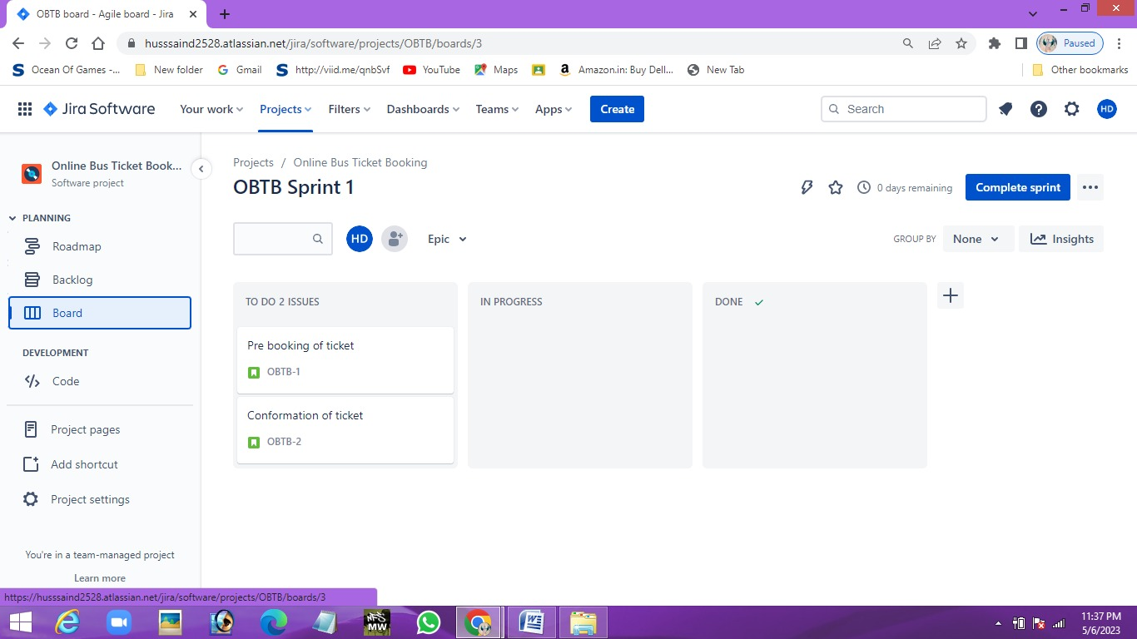

**UML Diagram:**

**USE CASE Diagram**

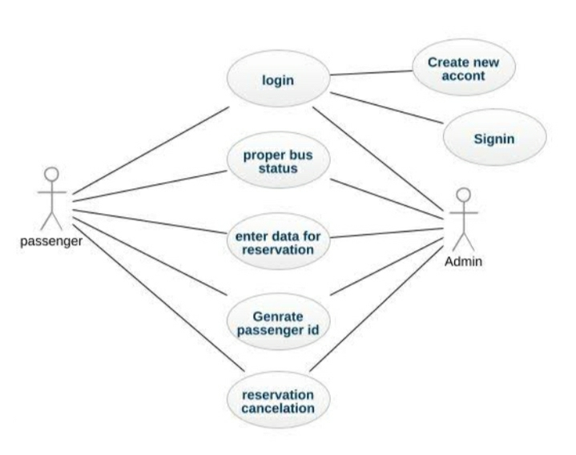

**User Stories:**

|  |  |  |
| --- | --- | --- |
| **Title:** Online bus ticket | **Priority**: High | **Estimation:** 2 |
| **User story: Tickets**  As a first time user of the Online bus ticket invoice software,  I want to be able to Online bus ticket invoices for my customer quickly and easily,  So that I can streamline my process and improve customer statisfication. | | |
| **Acceptance Criteria:**  Given that the new user want to book bus ticket Online invoice using software,  When the tickets are booked details are entered,  Then the payment can be done easily. | | |

|  |  |  |
| --- | --- | --- |
| **Title: Seats** | **Priority:** Low | **Estimation:** 2 |
| **User story: Passenger**  As a Passenger who is booking the ticket online ,  I want to be able to the pasenger to book the tickets online and do the payment easily,  So that I can provide accurate and efficient service to the passenger . | | |
| **Acceptance Criteria:**  Given that the passenger should be able to book more tickets in bus online invoice,  When the passenger books more tickets the amount should be calculated automatically in the software ,  Then the invoice should be generated accurately. | | |

**Test plan (Suite) for the above user using Jira.**

**Step-1: Install Zephyr scale-Test management for JIRA.**

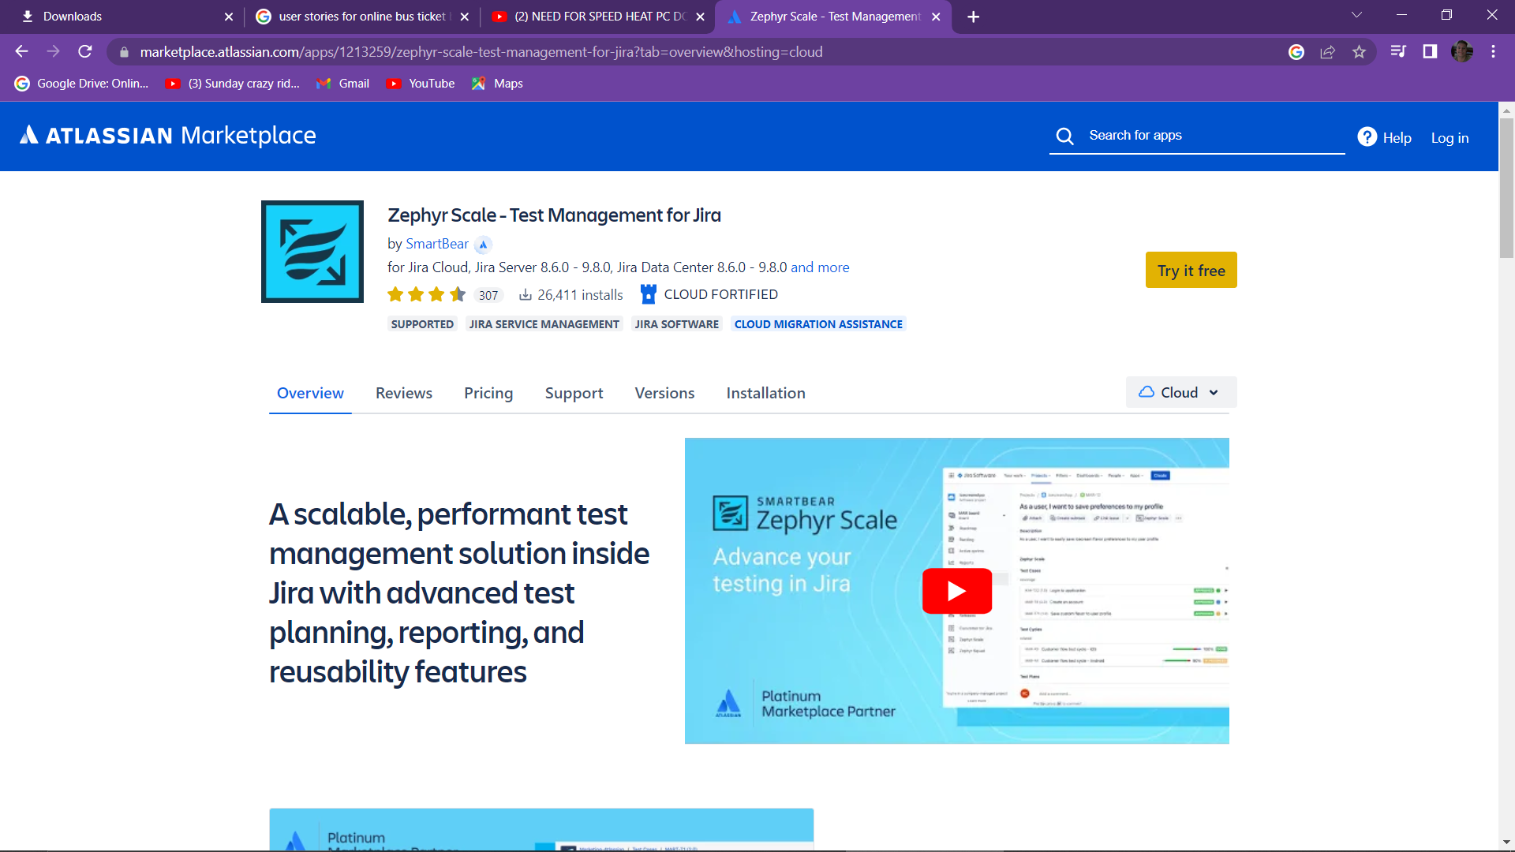

**Step-2: Create test suite(case) for your project**

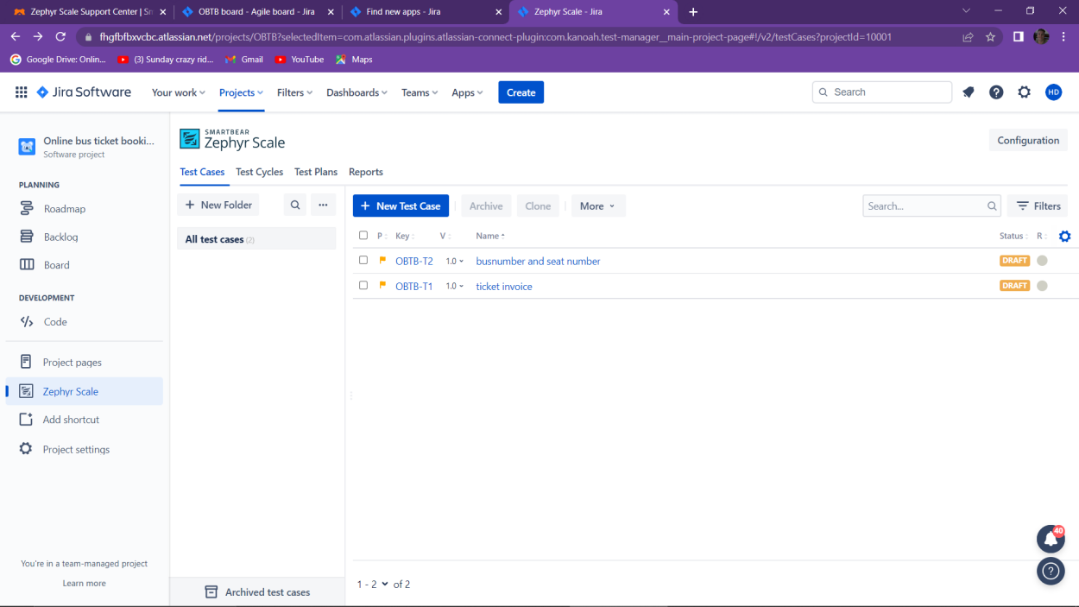

**Step-3: Add details for your test suite(case)**

